React JS Note

1. React

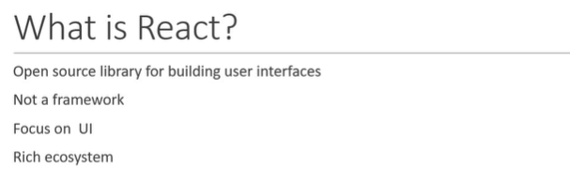

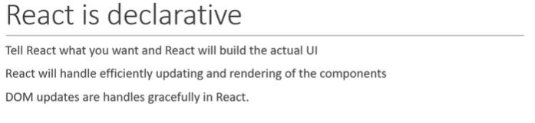

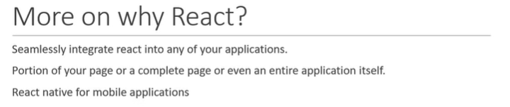

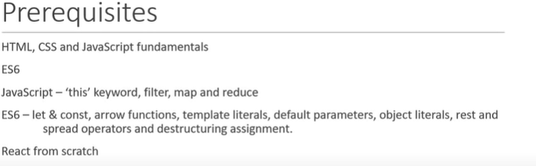

1. **Create App**

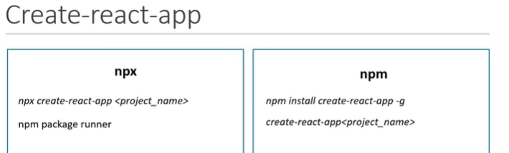

- npx create-react-app [project-name]

- npm install create-react-app -g <not recommand>

- npm start -> to start application

1. **Project Structure**

**-** package.json is all needs lib, start/build script, react version

1. **React Component**

- Component is Part of UI, reusable, can be nested inside of other Component

- Stateless Functional Componet -> JS Function return HTML

- Stateful Class Component -> ES6 Class -> Extends React.Component -> Render Method return HTML

1. **Functional Component**

- should only 1 Function in a Class ?

- import should be the same with function name or default export (recommend to easily understand)

- Use for -> Simple Function, Solution Without State, Responsible for UI

- Also Call Stateless/Dumb/Presentational

1. **Class Component**

- Use for -> Complex UI/logic

- Provide Lifecycle Hook

- Also call Stateful/Smart/Container

1. **Hook Update**

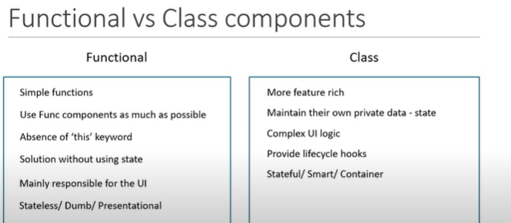

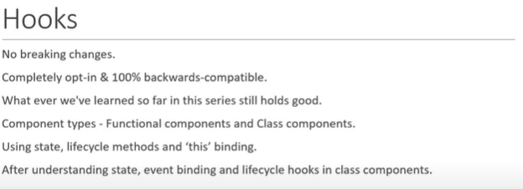

1. **JSX**

- Javascript XML

- JSX tag have tag name, attribute and children

- Make React Code to Simpler and elegant

- class replace with className

- use camelCase naming convention -> eg. onclick => onClick

1. **Props**

- data passing from **parent** to **child**, function parameter

- **immutable**

- props.name/ props.children

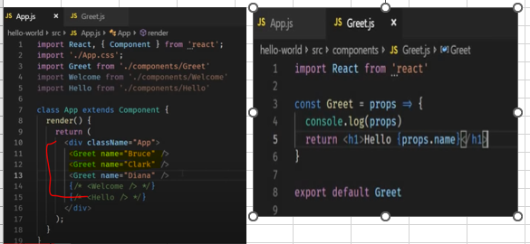

1. **State**

- manage within the same components

- variable declare within function body

- use **this.setState** to change state value

- **this.setState({ count: 1});**

- use callback function for custom logic

- use prevState to get previous State

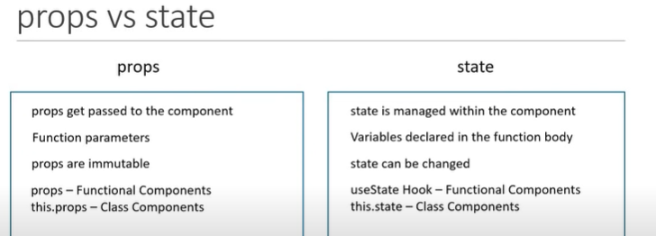

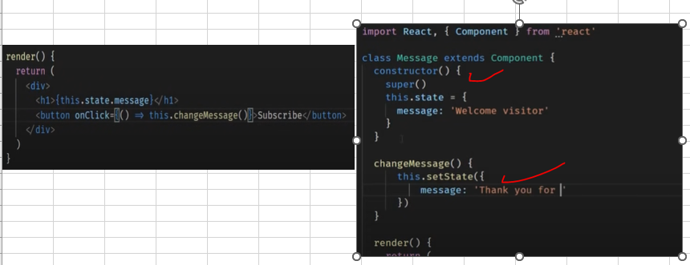

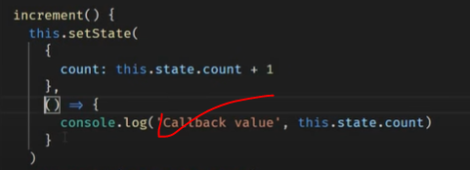

Added Custom logic in Call back

1. **Destructure**

- Destructure is ES5 Feature

- function component => const Gteet = ({name, heroName})

- class component => const {name, heroName} = this.props



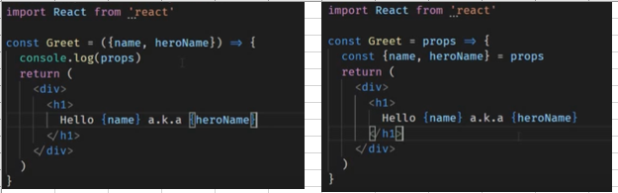

1. **Event Handling**

- functionalComponent -> onClick = {clickHanler} => *** do not add (), if add auto call function when init

- classComponet -> onClick = {**this**.clickHandler}

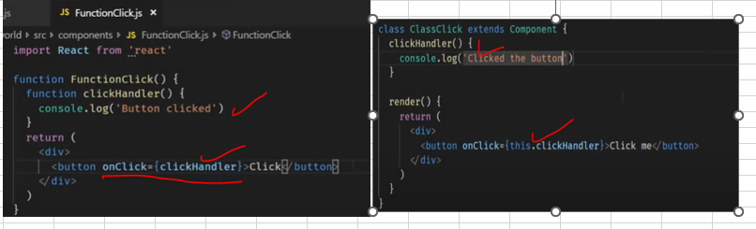

1. **Binding event Handler**

- onClick = {this.clickHandler.bind(this)} // not good because of performance

- onClick = {() => this.clickHandler()} =? *** call function and return, so need ()// not good

- // this.clickHandler = this.clickHander.bind(this)

- clickHandler = () => {

this.setState({m : test})

}// better

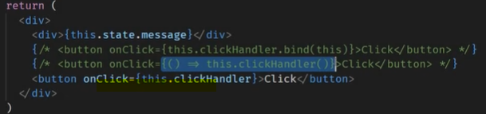

1. **Method as Prop**

Pass Method as a prop

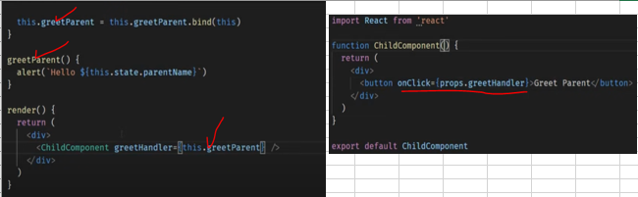

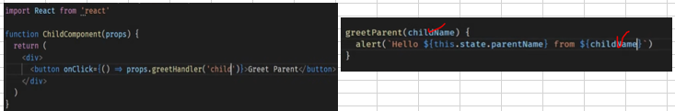

1. **Conditional Rendering**

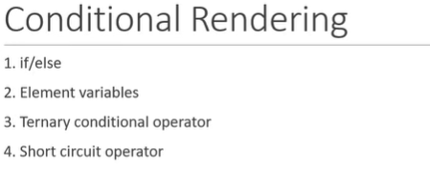

- if/else => add if/else condition in render return method and if change condition need to reload/re-render the jsx

- Element Variable => declare variable and update value based on if/else condition in render method

- Ternary operator => return ( this.state.login ? <div>login</div> : <div>guest</div> )

- Short Circuit Operator => return ( this.state.login && <div>login</div> )

1. **List Rendering**

- names.map(name => <h3>{name}</h3> )

- const nameList = names.map(name => <h3>{name]</h3>);

- return <div>{nameList}</div>

# for parent and child

- parent => const personList = persons.map (person => <Person person={person} />

return <div>{personList}</div>

- child => function Person(person) { return ( {person.name}); // but key is missing for the list

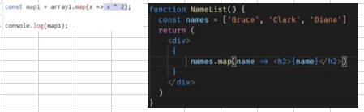

1. **List and Key**

- handline ui efficient

- to detect which element is added/remove

- parent => const personList = persons.map (person => <Person key={person.id} person={person} />

1. **Index as a key**

- const nameList = names.map( (name, index) => <h3 key={index}>{name]</h3>);

- use for => 1. item don't have unique id, 2. list is static and will not change, 3. list will be never filter or re-order

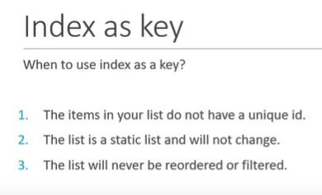

1. **Styling React JS**

- 1. css stylesheet, 2. inline style, 3. CSS modules, 4. CSS in JS lib

- import CSS class => import './style.css';

- let className = props.primary ? 'primary' : '';

- <h1 className = {className}> test </h1>

import styles from './appStyles.module.css'

<h1 className={styles.success}>success</h1>

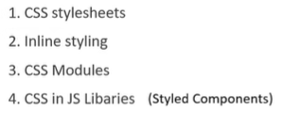

1. **Form Handling**

- handleUsernameChange = (event) => {

this.setState({ username: event.target.value });

}

- <input value={this.state.username} onChange={this.handleUsernameChange} />

- submit button will trigger to default HTML form submit and need to disable

- <form onSubmit= {this.handleSubmit}>

- handleSubmit = event = { alert('${this.state.username}')}

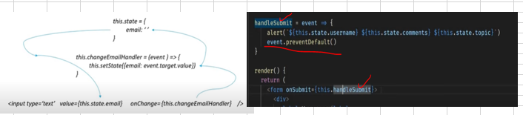

1. **Lifecycle**

- **Mounting** -> component is being created and inserted into DOM

-> constructor, static getDerivedStateFromProps, render and componentDidMount

- **Updating** -> component is being re-render as a result of changing props/state

-> static getDerivedStateFromProps, shouldComponentUpdate, render, getSnapshotBeforeUpdate, componentDidUpdate

- **Unmounting** -> component is being removed from the DOM

-> componentWillUnmount

- **Error Handling**-> Error during rendering, in a lifecycle method/ constructor or child component

-> static getDerivedStateFromError and componentDidCatch

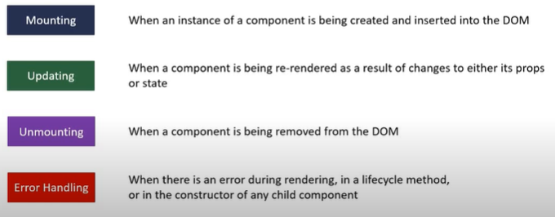

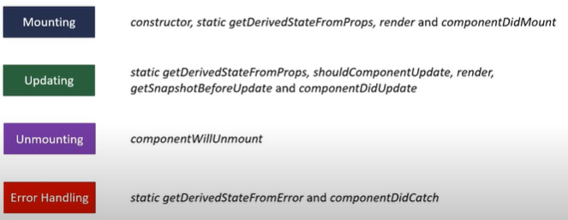

1. **Component Mounting Lifecycle**

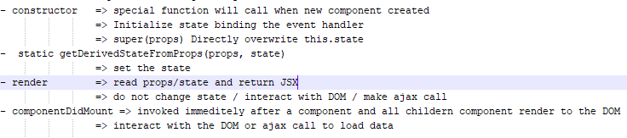

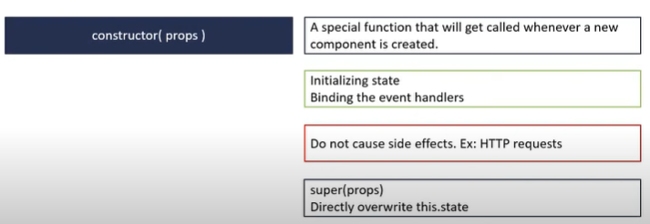

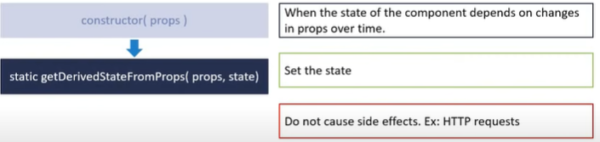

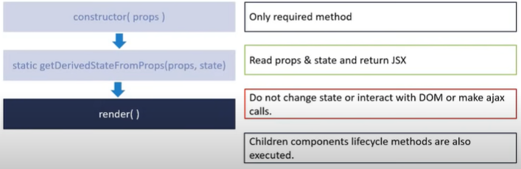

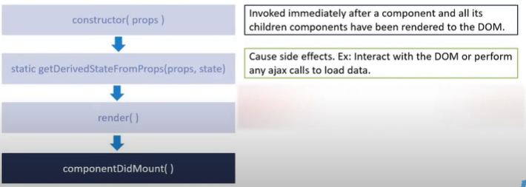

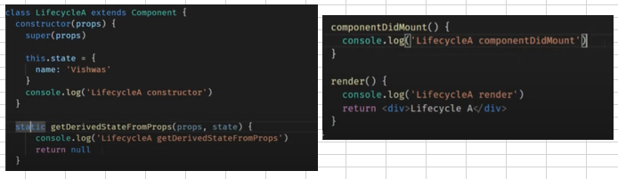

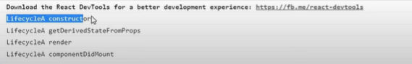

Parent & Child

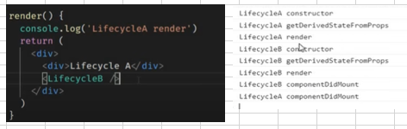

1. **Updating Lifecycle**

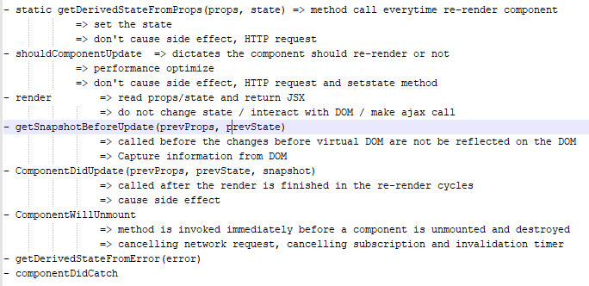

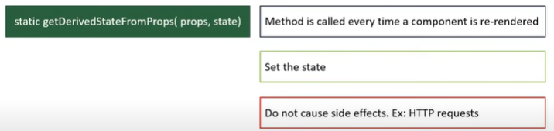

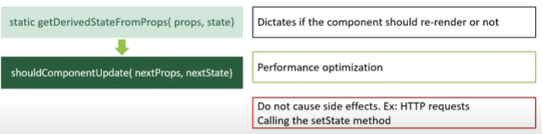

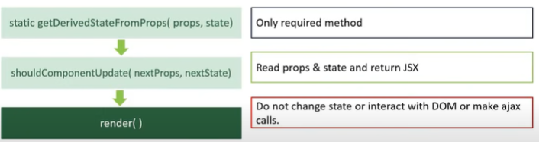

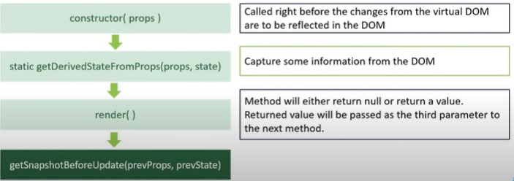

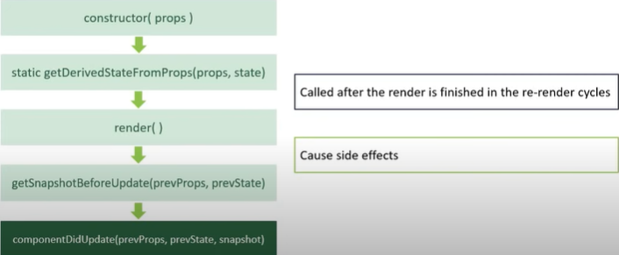

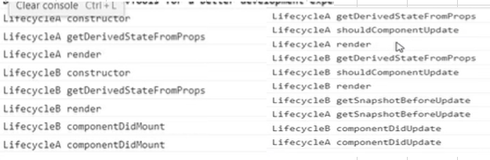

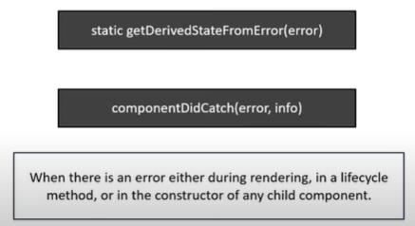

1. **Fragment**

- return single element without DIV

- <React.Fragment> <div></div><h3>test</h3></React.Fragment>

1. **Pure Component**

- pure component never re-render/ onetime only

- if parent component is Pure, child also pure

- never mutate state, always return new object state

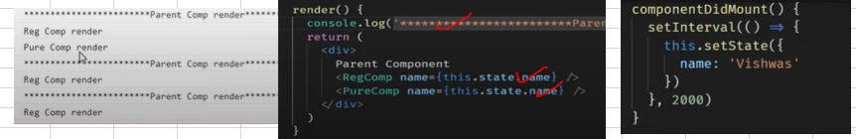

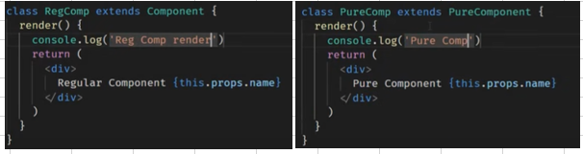

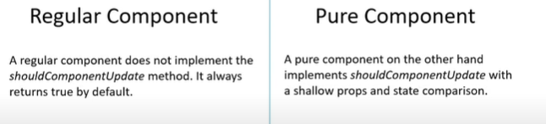

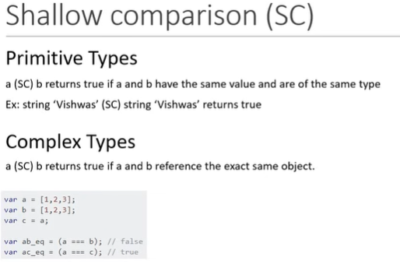

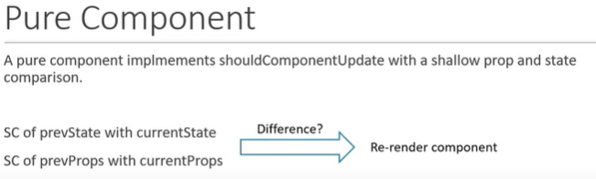

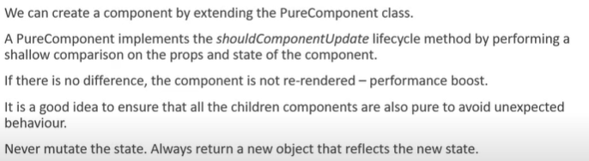

1. **Memo Component**

- same like pure component

- component never re-render and no changes props

- react.purecomponent for class component and react.memo for function component

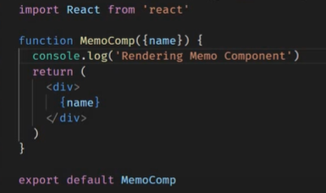

1. **Refs**

- this.inputRef = React.createRef();

- <input type=text ref={this.inputRef}/>

- this.inputRef.current.value

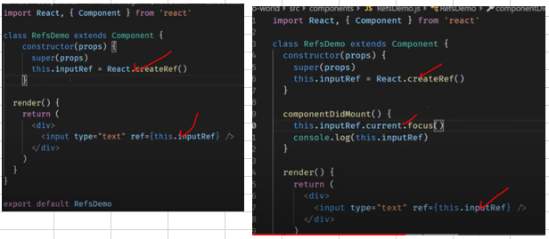

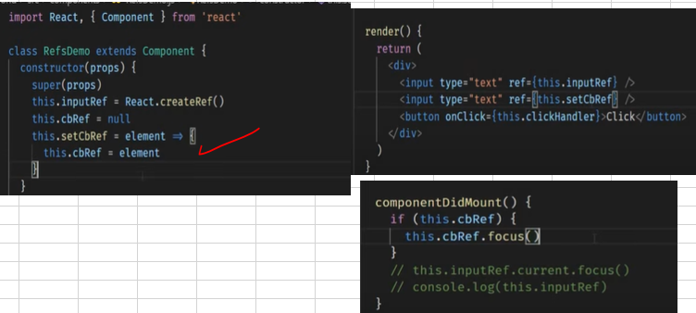

1. **Ref vs Class Component**

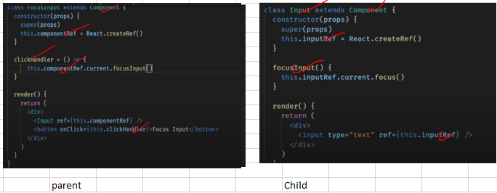

1. **Forward Ref**

- forward ref to cild component

- 1. create ref in parent component and pass ref to child

eg. <FRInput ref={this.inputRef} />

and child => const FRInput = React.forwardRef((props, ref) => {

<input ref= {ref} />

}

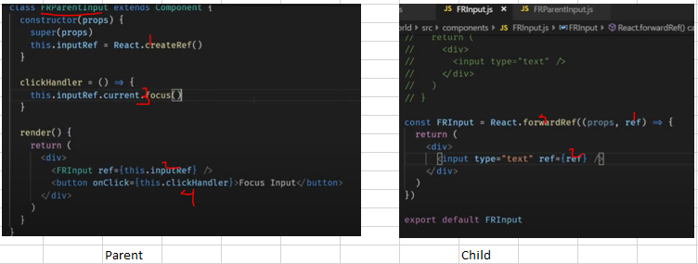

1. **React Portals**

- create react outside root DOM node

- create another div id='portal' under index.html

- create ReactDOM.createPortal(<div>test</div> , document.getelementbyid('portal')) in js file

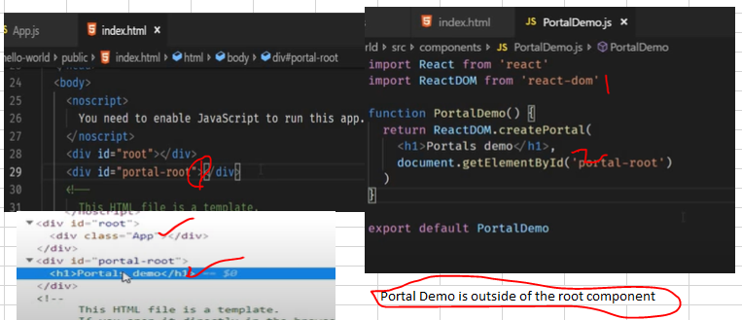

1. **Error Boundaries**

- react component that catch javascript error from child component, log these errors and show fallback UI

- getDirectiveStateFromError and componentDidCatch

- Error Boundaries is only for production, for dev you will be still see all error log

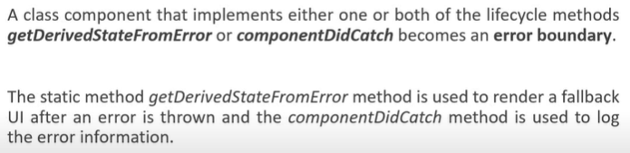

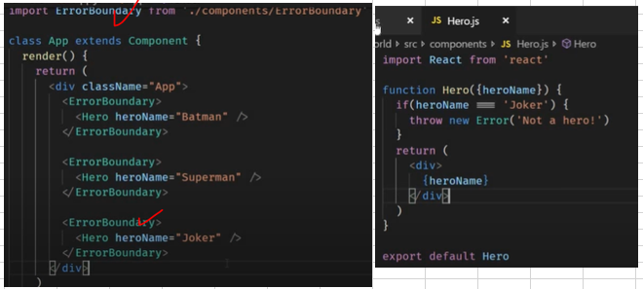

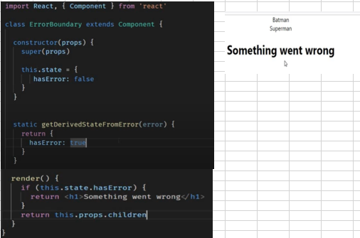

1. **Higher Order Component**

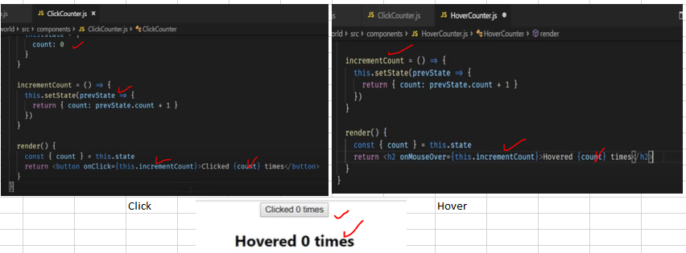

**Should be reusable code**

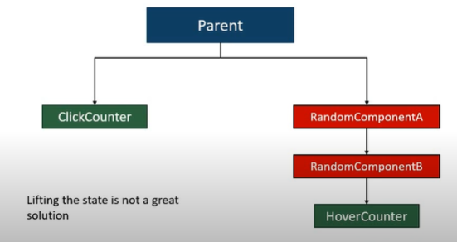

**Need common function for between cross component**

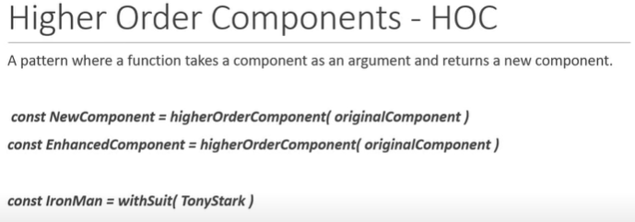

HOC is accept original component and return new component

1. **React HTTP**

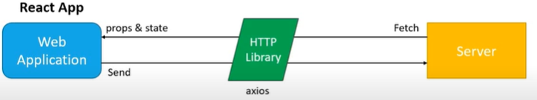

**Npm install axios**

[**https://jsonplaceholder.typicode.com/**](https://jsonplaceholder.typicode.com/)**( to test)**

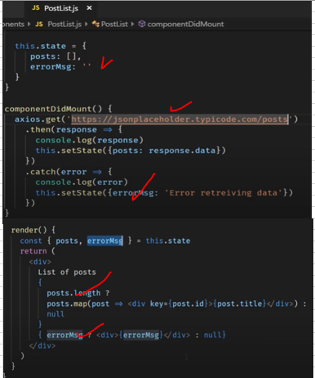

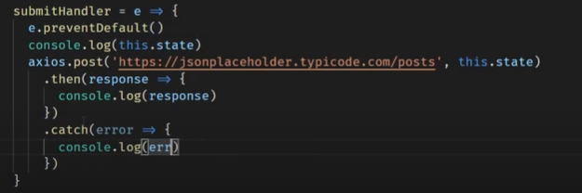

1. **HOOK**

- min react version 16.8

- state and other features without writing class

- hook don't work in class component

- avoid confustion with 'this' keywork

- allow to reuse stateful logic

- organize the logic inside a component onto reuse

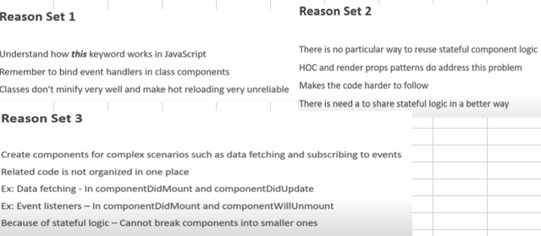

1. **Rules of HOOK**

- only call in top level

- don't call hook in loop, conditions or nested functions

- only call hook in react function

- only call in react functional component

- state is always object in class

- with useState hook, the state don't have to be object

- use state hook return an array with 2 elements

- the first element is the current value of the state, the second element is state setter function

- when dealing with object or array, always make sure to spread your state variable and then call setter function

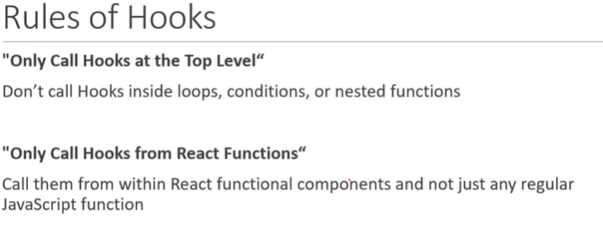

1. **useState Hook**

- const [count, setCount] = useState(0); // cal, method and default

- <button onClick={() => setCount(count+1)}

- const incrementFive = () => {

for(let i=0; i<5; i++) (setCount(prevCount+1));

}

- const [name, setName] = useSate({fName:'', lName:''})

- <input value={name.fName} onChange={e => setName({...name, fName: e.target.value})}// clone from prev state

- const [items, setItems] = useState([])

- const addItem = () => {

setItem([...items, { id: items.length, value: 2} ])

}

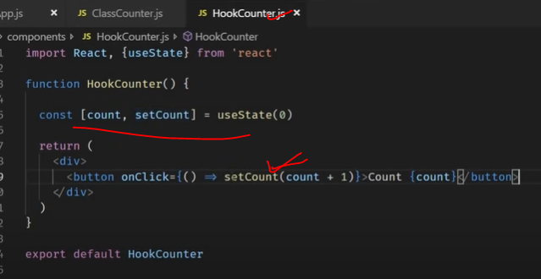

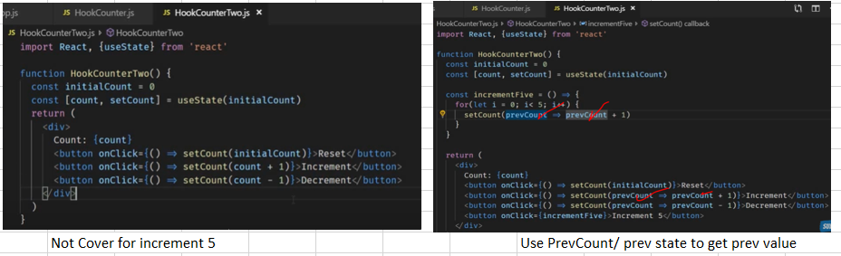

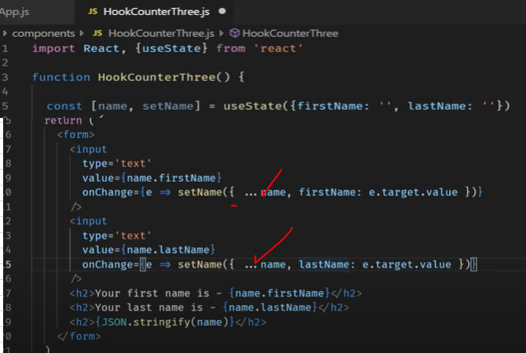

**… is clone from prevState**

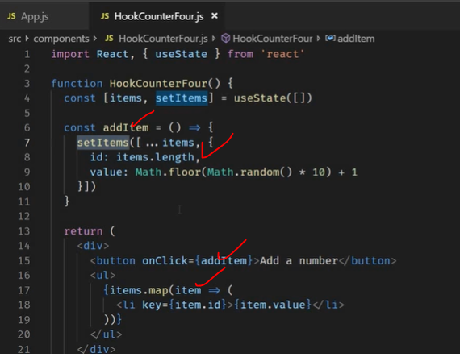

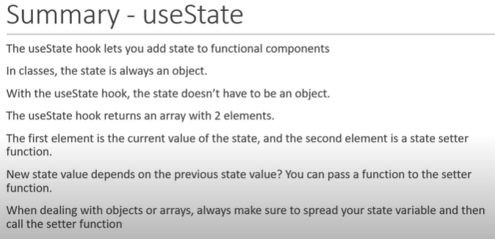

1. **useEffect after render**

=====> useEffect after render

- useEffect will call after every render/re-render component(same componentDidMound/componentDidUpdate/ compomentWillUnmount)

=====> Conditional run effect

- useEffect(() => { }, [count]); // second parameter is condition to run useEffect method

=====> Run Effect one time only

- useEffect(() => { }, []); // empty array to run 1 time only

=====> UseEffect with cleanup

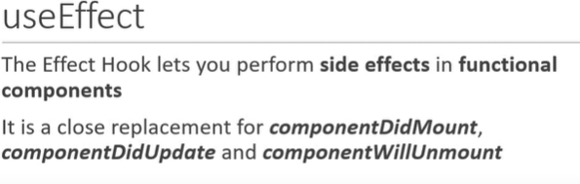

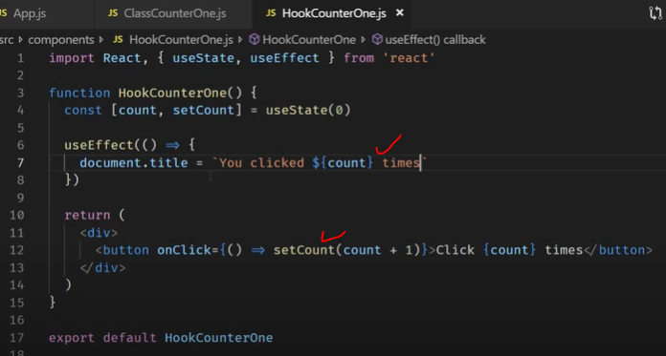

Fetching data useEffect (**should pass [] for 1 time load from server**)

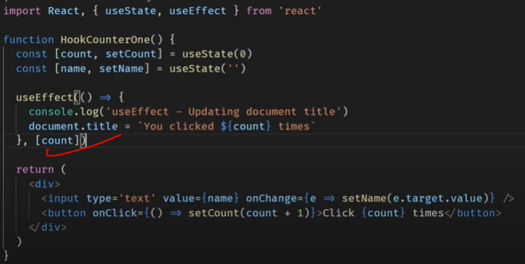

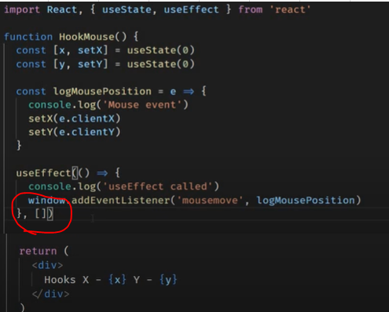

Only 1 time Load

User effect with Clean up function => mean unsubscribe function ( use return fun

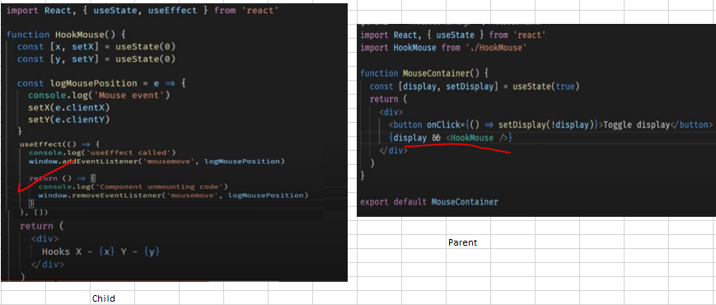

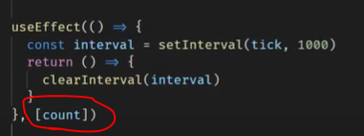

1. **useContext**

- context is a way to **pass data through the component tree without passing props down manually**

- useContext

- useState - relative to state

- useEffect - relative to side effect

- useContext - context API

- useReducer - relative reducers => useReducer(reducer, initState)

- reducer(currentState, action)

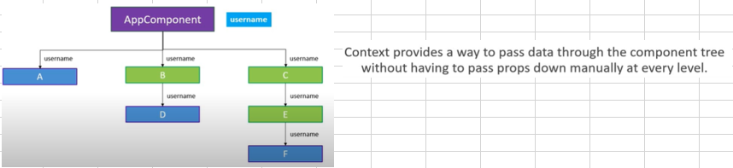

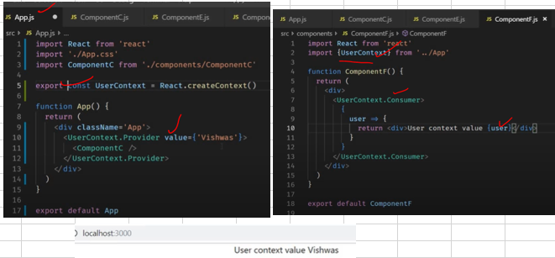

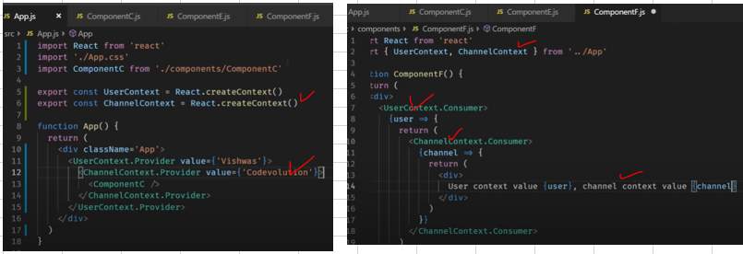

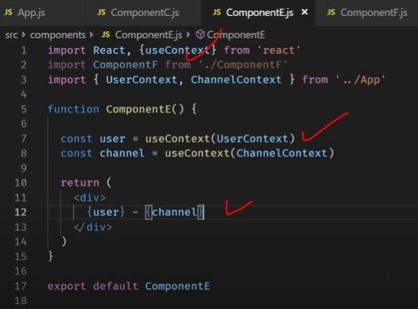

1. **useReducer**

- useReducer => is a hook that use for statemanagement, useReducer is related to reducer function

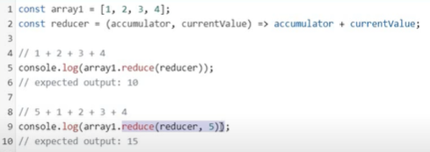

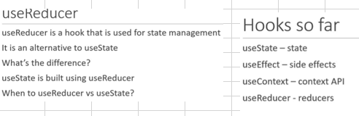

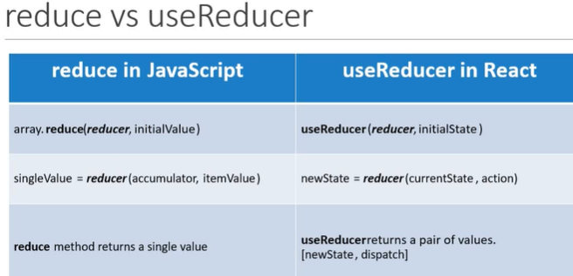

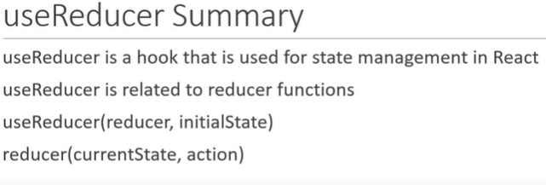

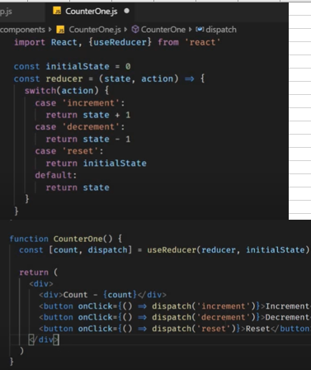

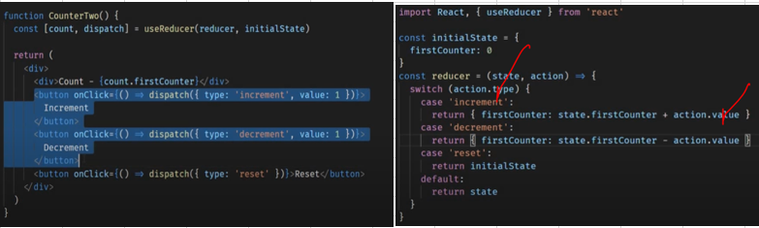

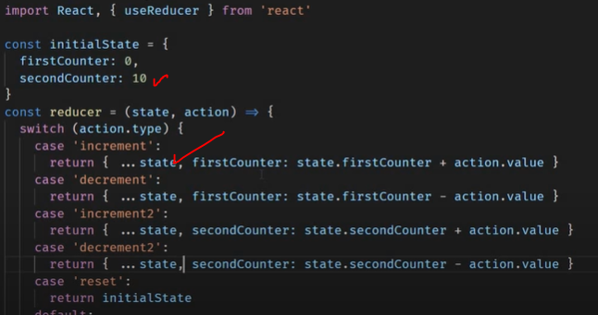Clone

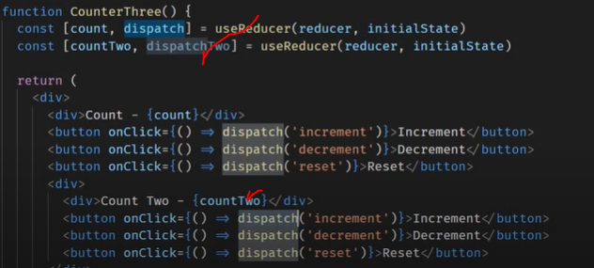multiple reducers

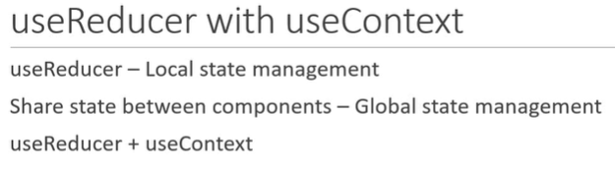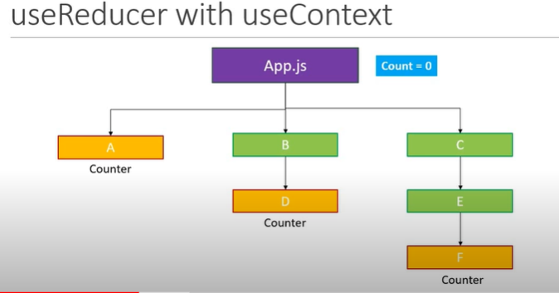

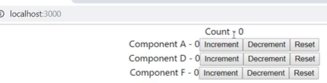

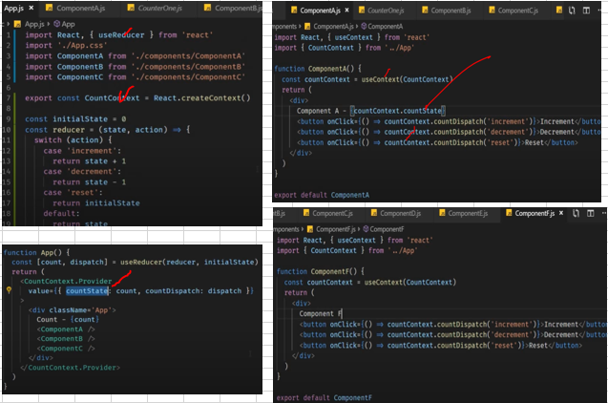

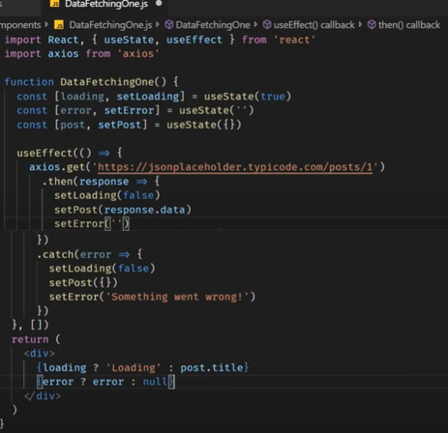

- **Usestate** -> Number, string, boolean , **usereducer** -> Object or array

- **usestate** -> one or two number of tran , **usereducer** -> too many number of tran

- **useSatte** -> no read state tran , **useReducer** -> yes read state tran

- **useState** -> no business logic, **useReducer** -> complex business logic

- **useState** -> local val, **useReducer** -> global val

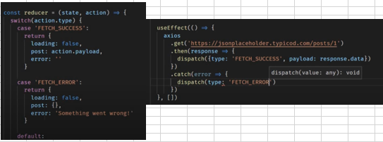

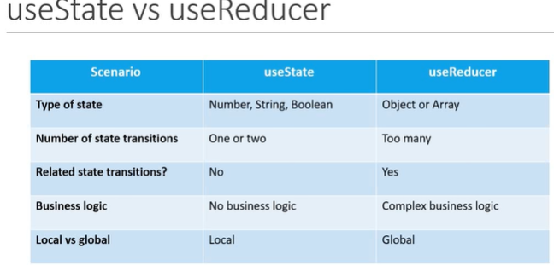

1. **UseCallback**

- only re-render specific component for better performance

- const incrementAge = useCallback(() => {setAge(age+1)}, [age]) // re-render based on age change

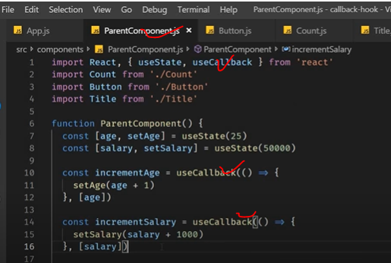

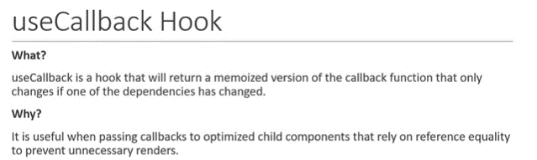

1. **UseMemo Hook**

usMemo is a hook that will only re-compute that one of the dependancy changed

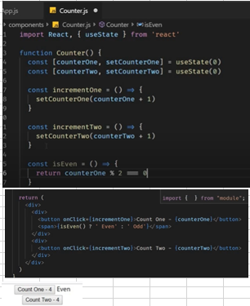

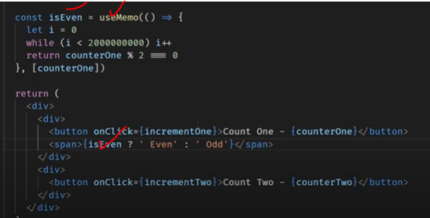

1. **UseRef Hook**

useRef is hook to access DOM node directly from functional component

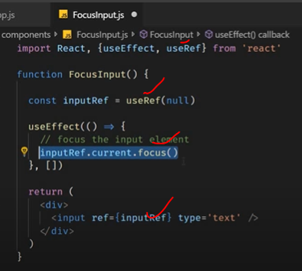

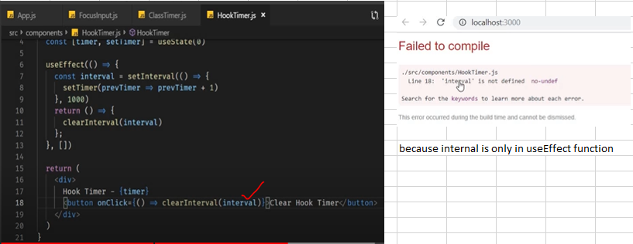

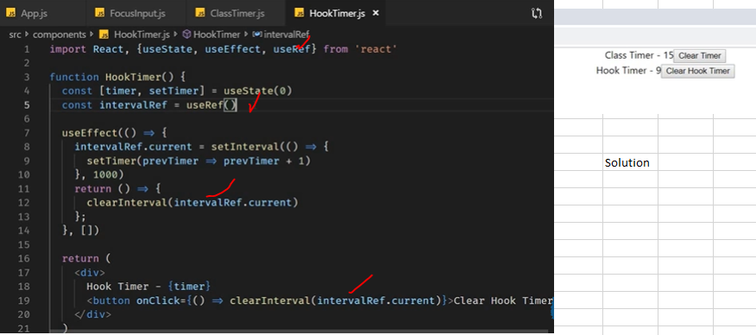

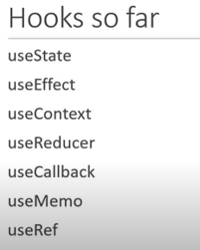

1. **Custom Hook**

